Appendix:

1.1

EMBLEM examples





‘Recycle’

United Nations

Yin and Yang

Appendix:

1.2 partner logos



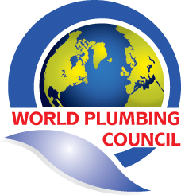

WorldSkills
(Choice of colours available)

IAPMO
(International Association of Plumbing
and Mechanical Officials)

World Plumbing Council

Appendix:

1.3 images

CPC_2015_School (20 images):

Appendix:

1.3 images (CONTINUED)

CPC_Projects (21 images):

Appendix:

1.3 images (CONTINUED)
CPC_2015_Stock_images (44 images):

